## JavaScript Linters and Formatters

Linters and formatters avoid code chaos – confusion, inconsistent, unpredictable, and messy code.

Clean and consistent code builds confidence.

ESLint – highlights problems – missing semicolons, unused variables, using var instead of let or const, missing return value, calling an undefined variable.

Prettier – scans our file and applies a consistent structure – indentation, quotes, semicolons, empty lines, curly brackets tc.

ESLint analyses code for problems, prettier formats code consistently. It is like combination of spellcheck and autocorrect.

Schematic command – npx eslint --init

Use ESLintPluginSecurity plugin for ESLint with mentioned rules –

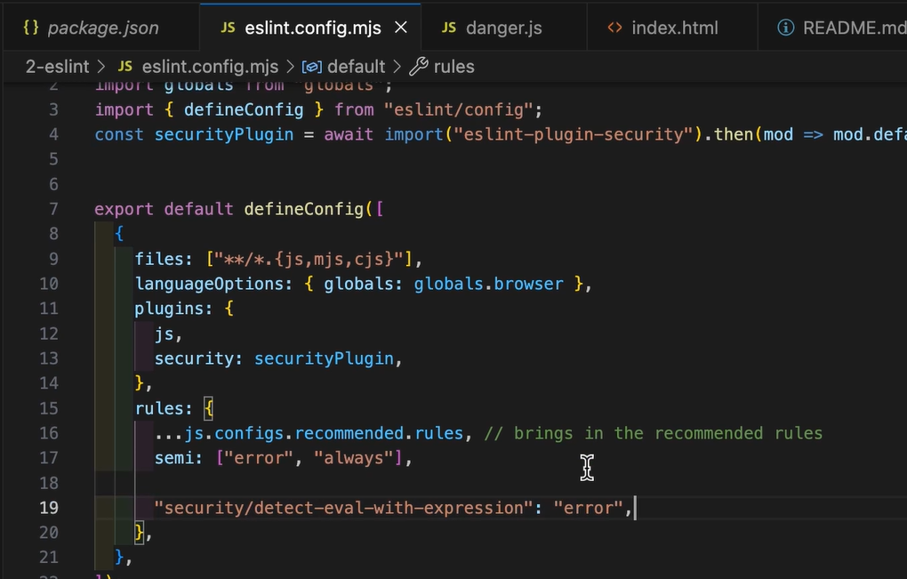

Auto fixing flag command – npx eslint app.js --fix

Prettier is an opinionated code formatter means it has strong opinions on how code should look and it applies those opinions to our code, no warnings just fixes.

ESLint like grammar checker, prettier like document formatting. ESLint checks logic, Prettier takes care of layout.

Command to run prettier on all files – npx prettier . --write

Default prettier options –

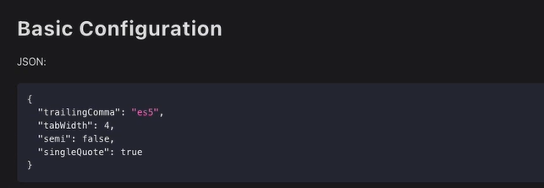

We can use .prettierignore file to ignore some of the files from formatting –

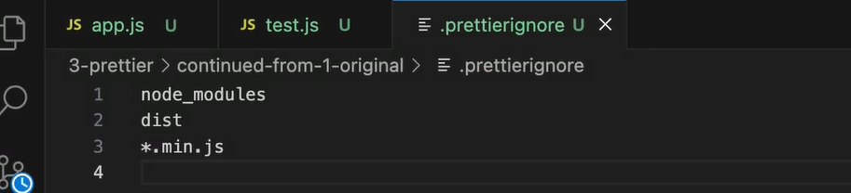

To avoid the conflicts between prettier and ESLint, we should use official plugin for prettier from ESLint i.e. eslint-config-prettier. This plugin will disable the ESLint rules that would conflict with prettier. It will tell ESLint, stick to logic, let prettier handle the formatting.

Add prettierignore file, delete prettier direct dependency.

In our editor we should install prettier extension and enable “format on save” in CI run prettier and fail the build if files aren’t formatted. And use as a pre-commit hook with lint-staged and husky.

Also choose default formatter as Prettier – Code formatter extension –

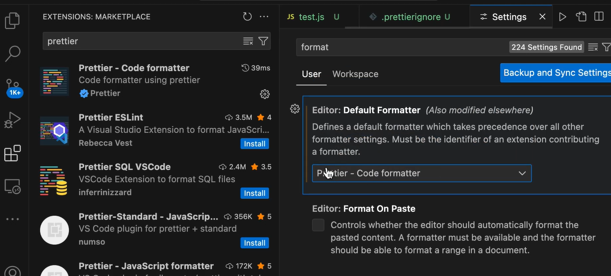

Prettier extension doesn’t respect the files like prettierignore so we should use prettier through CLI commands with custom script not the VS Code extension.

Using Biome tool – speed (built on rust), simplicity (zero config by default).

Command – npm i -D -E @biomejs/biome, biome format –write, biome lint

Command – do linting and formatting at same time – biome check --write

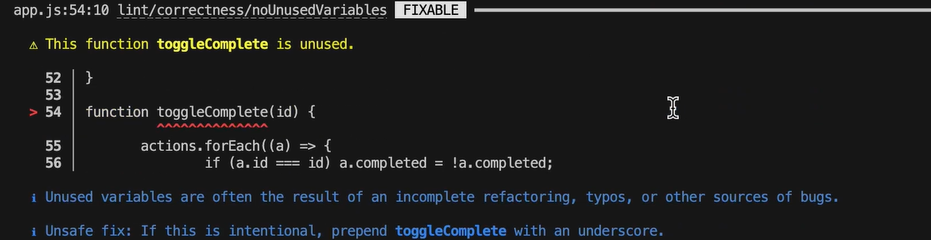

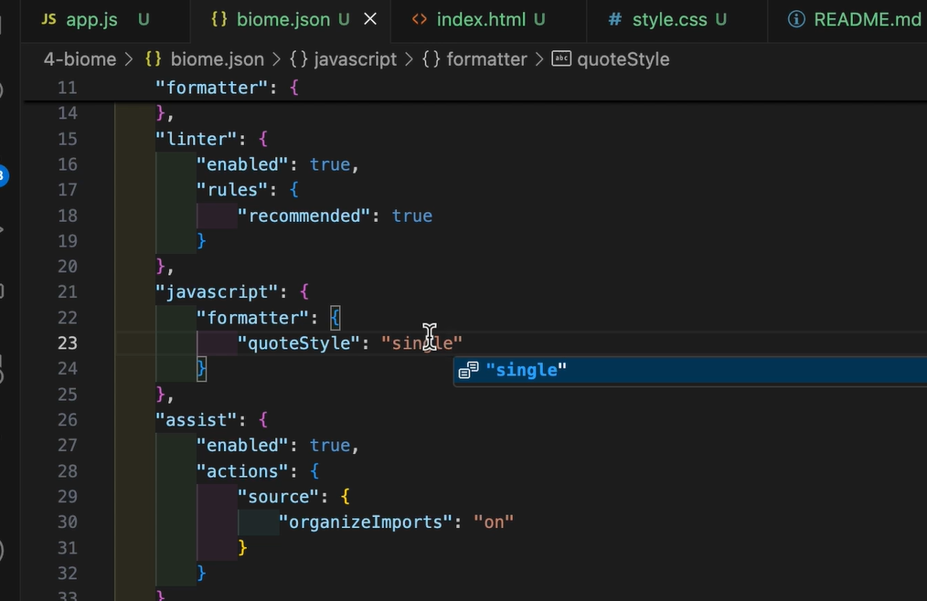

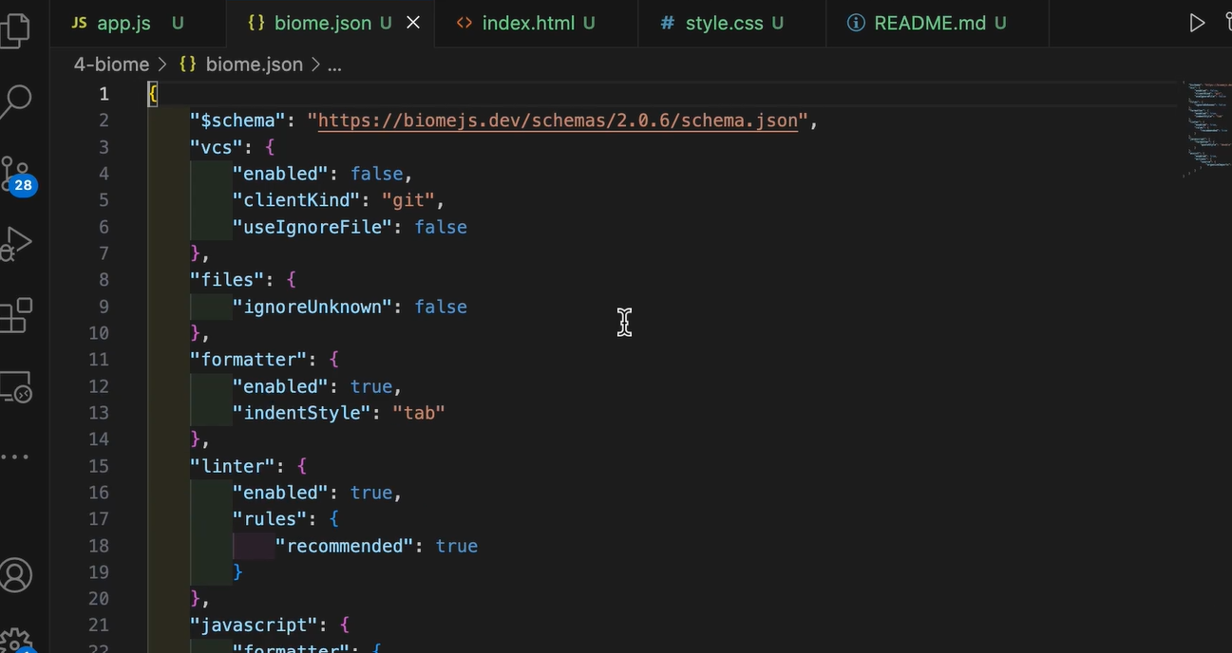

Language support –

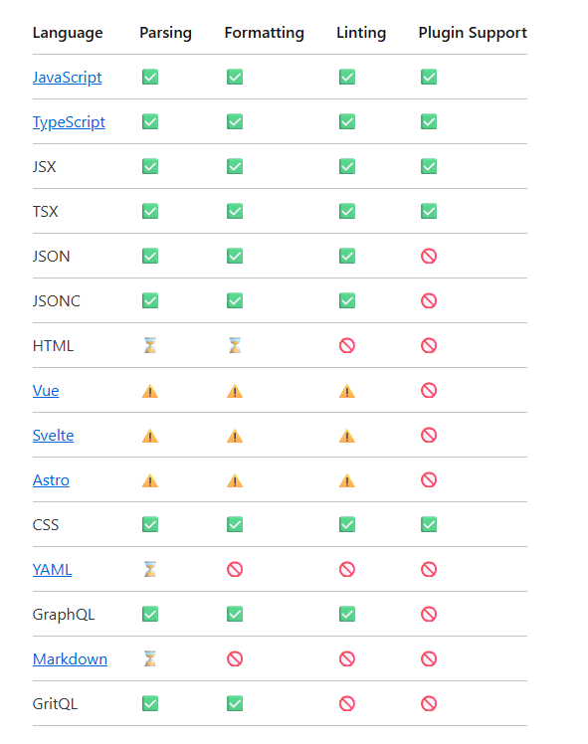

It has below category of the rules –

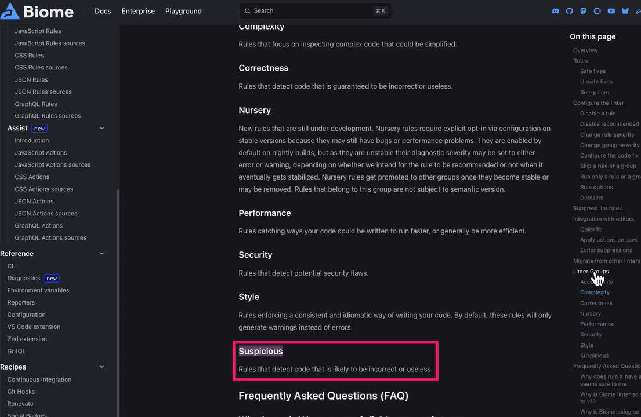

ESLint + Prettier vs. Biome

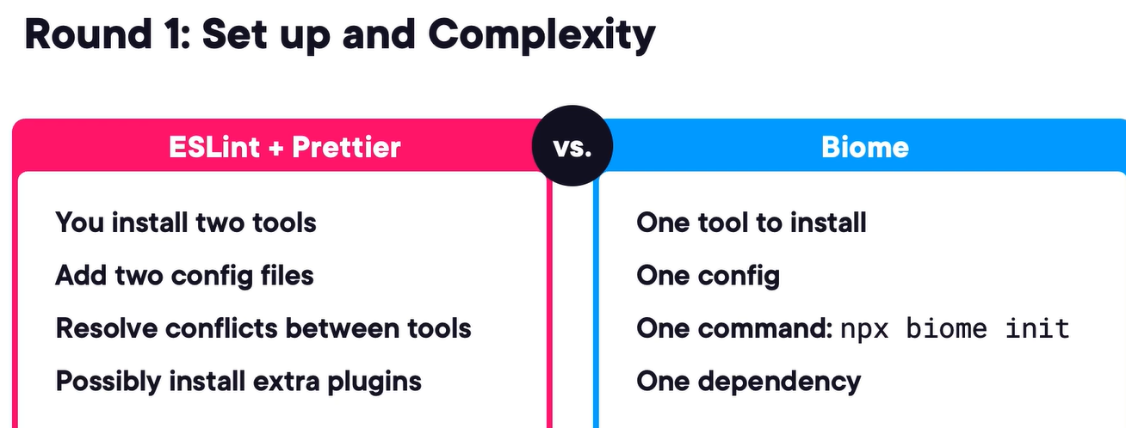

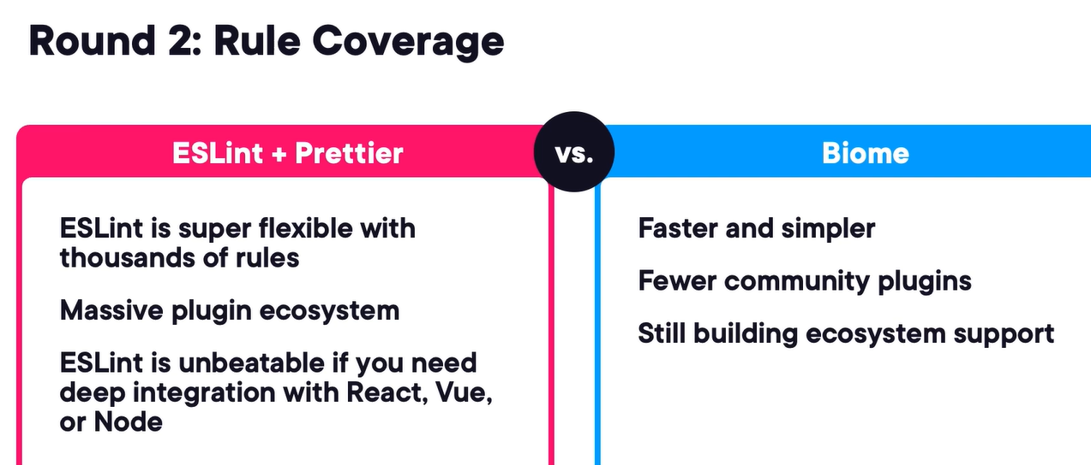

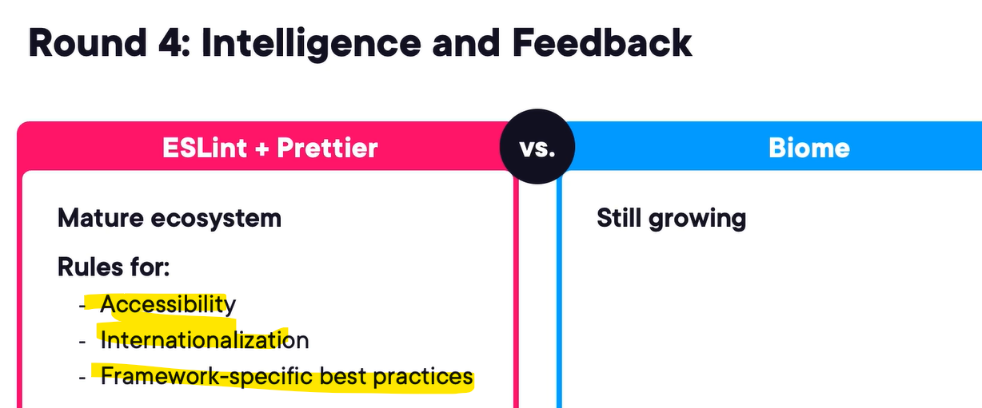

If our project needs deep linting, plugin support or is already using ESLint then stick with ESLint + Prettier, but if we are starting fresh and want speed and simplicity Biome might be perfect for you.

GitHub action for formatting and linting –

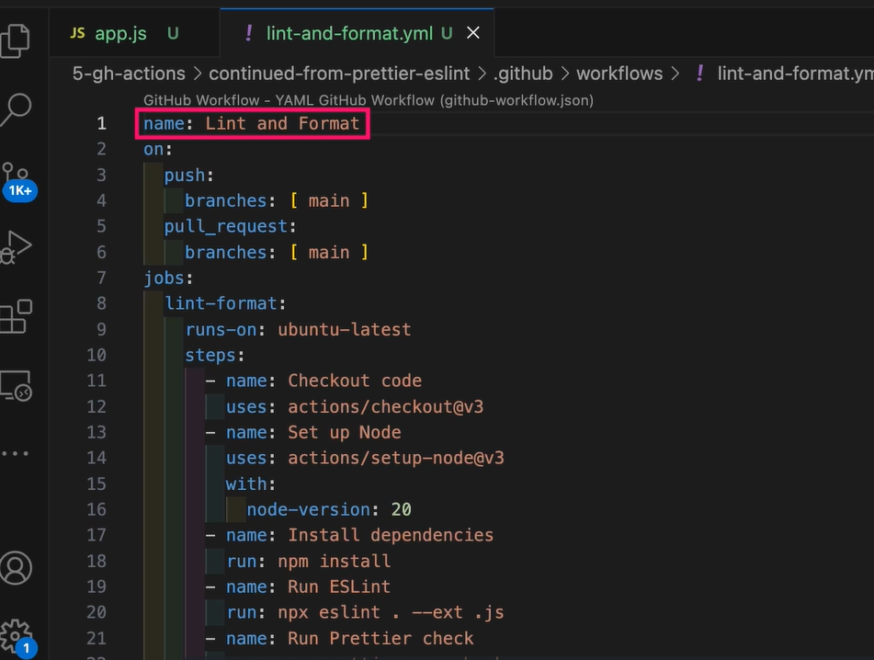

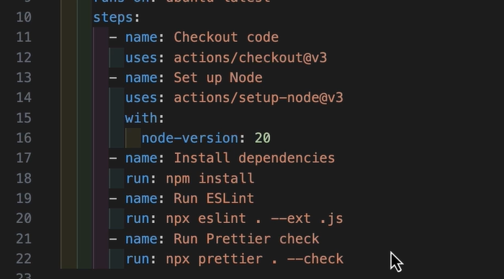

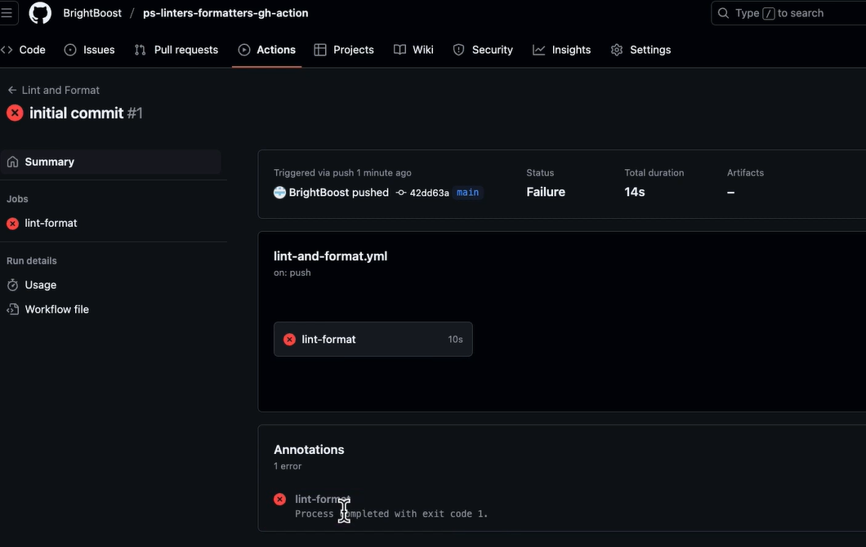

We can auto-fix on PRs using a bot fixing formatting issues automatically by using GitHub Super Linter or Danger.js.

We should try to implement coding style or rules through linting or take a base rule from opinionated, well-maintained and widely used libraries like Airbnb, StandardJS, Biome.

We should implement Linters and Formatters in our editor, as a Git pre-commit hook and our CI/CD pipeline.

We can put shared configs either in the project level, or in the npm package on remote with versioning or in the monorepo structure or dev tool.

Things to do to avoid drift – lock the toolchain by putting all the dependencies in the package.json file don’t rely on global install, configure it on “format on save”, use pre-commit hooks, enforce linting and formatting in CI by using GitHub actions, also teach people why we are doing it.

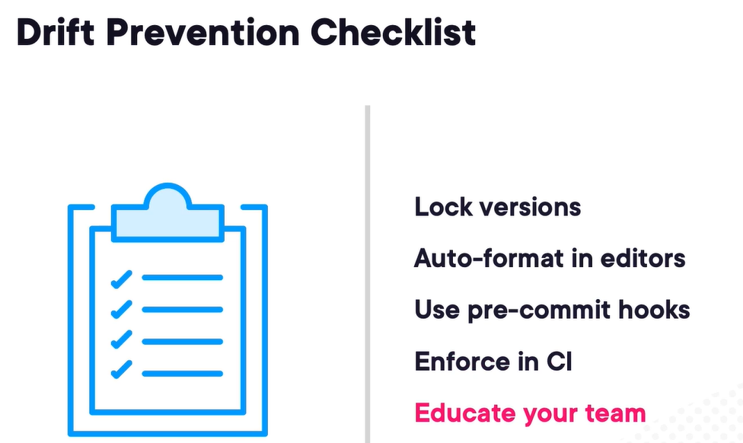

## JavaScript Testing Practices and Techniques

Mocks help us to track how function was used like how many times a function was called or which arguments were used to call the function.

Stubs are similar to mocks but they replace the real behavior with something predictable. They allow us to verify the behavior of a function without having to worry about external dependencies like APIs, database or other IO operations.

Testing methodologies – test-driven development, behavior-driven development, test-last development (classic approach).

We should use TDD when logic-heavy code (safe iterations), tight feedback loop and comfortable writing tests early. BDD is great when business rules or stakeholder input, need a shared language.

Best Practices –

Rule 1 – Single purpose per test

Instead of this

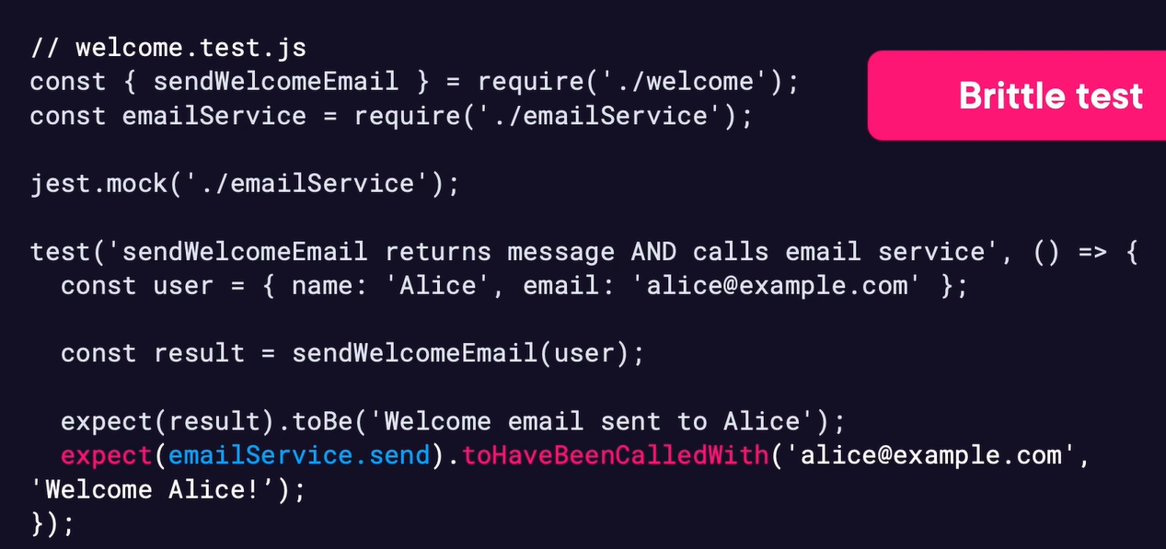

Use this

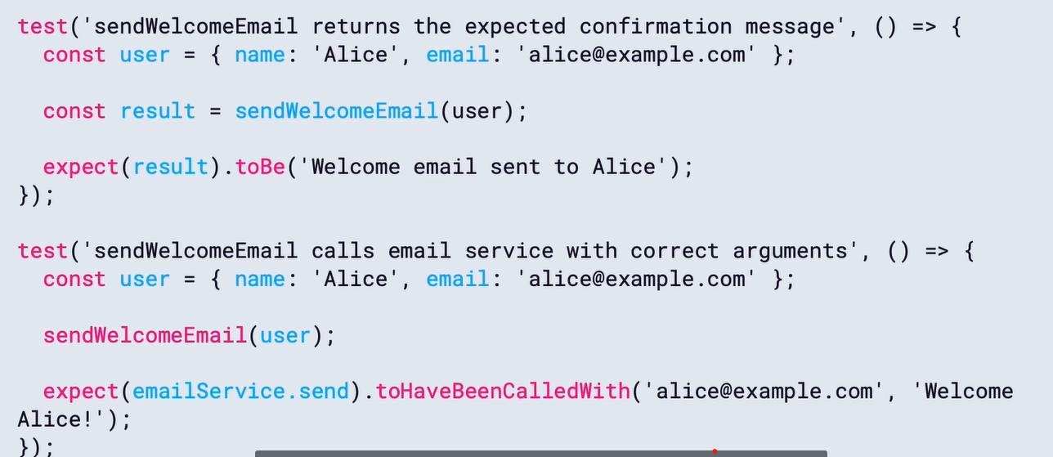

Rule 2- Structure tests with the AAA pattern –

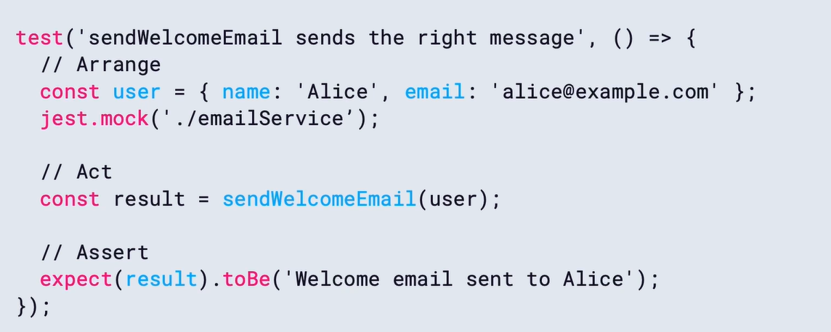

Rule 3 – Use clear and Descriptive Test Statements – it will help others to understand what we are testing without reading any code.

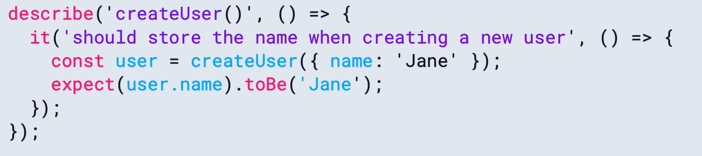

Rule 4 – Structure tests with nested describe blocks (use multiple describe block for related test cases as a grouping)

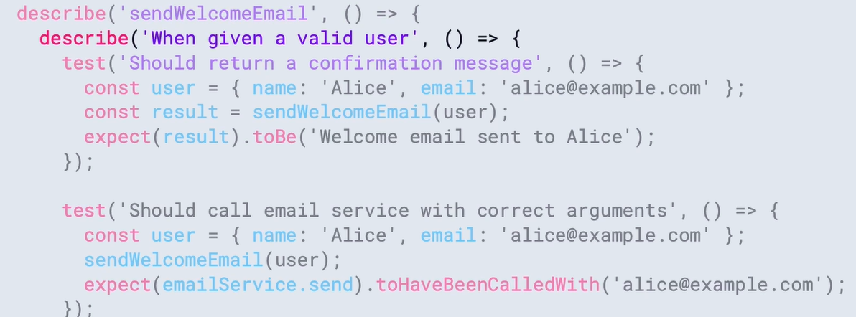

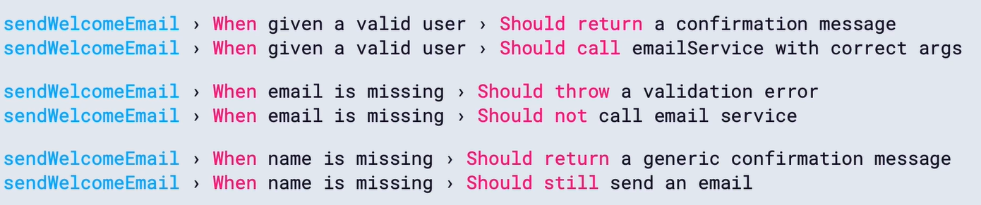

Rule 5 – Keep Test fixtures close to code

Instead of using *.json file refer the data in the code itself by using factory function –

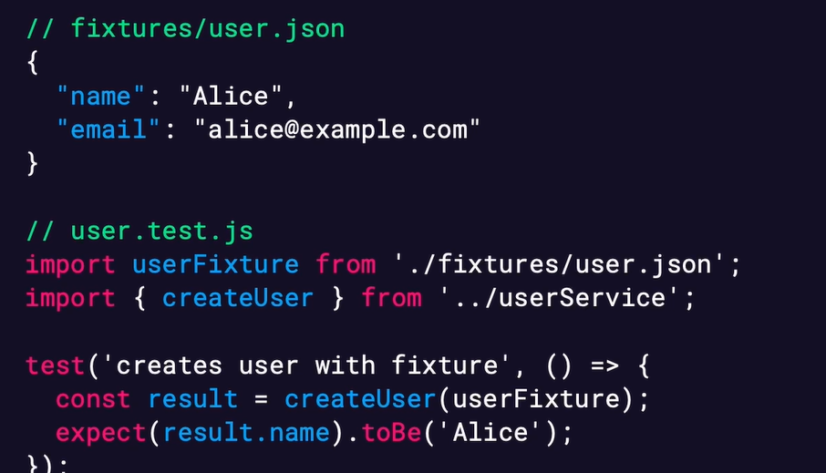

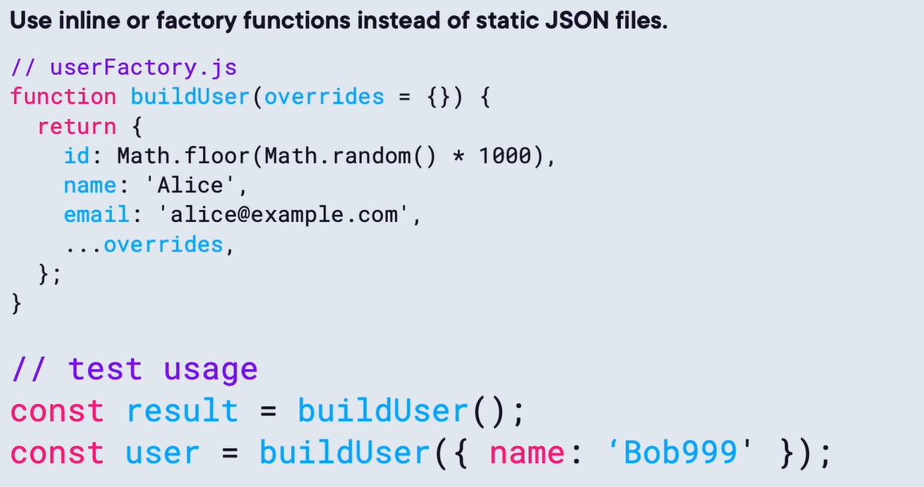

Rule 6 – Use mocks to assert calls and arguments, not replacing implementation details. It is useful when we are not interested in how method works but only that it was invoked correctly.

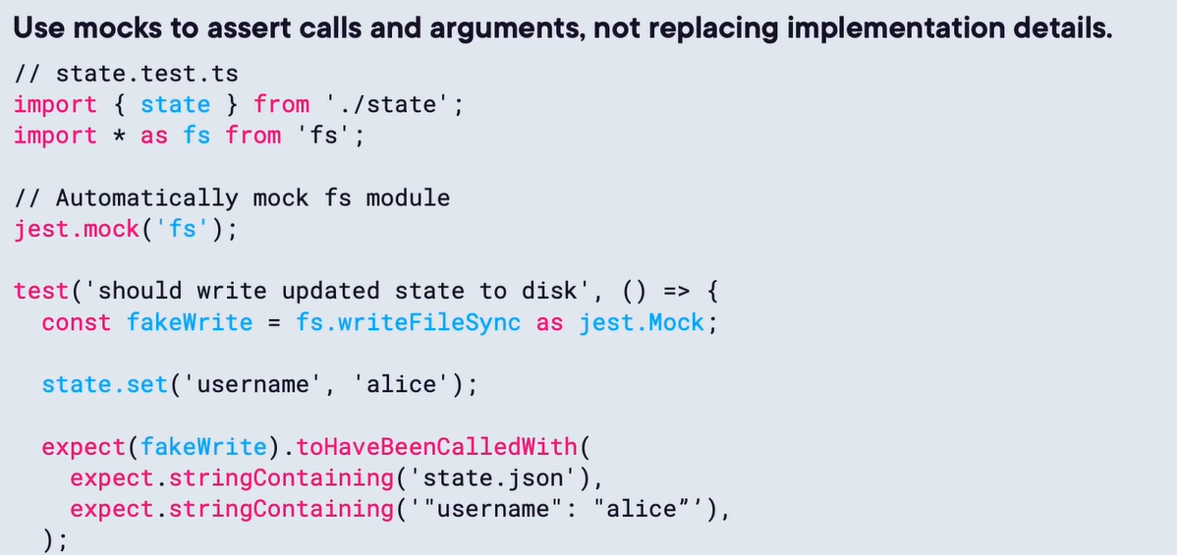

Use stubs to replace the actual implementation with controlled behavior – like instead of calling the directly database API, we can stub it with in-memory database which will be faster and don’t give any network or other related issue.

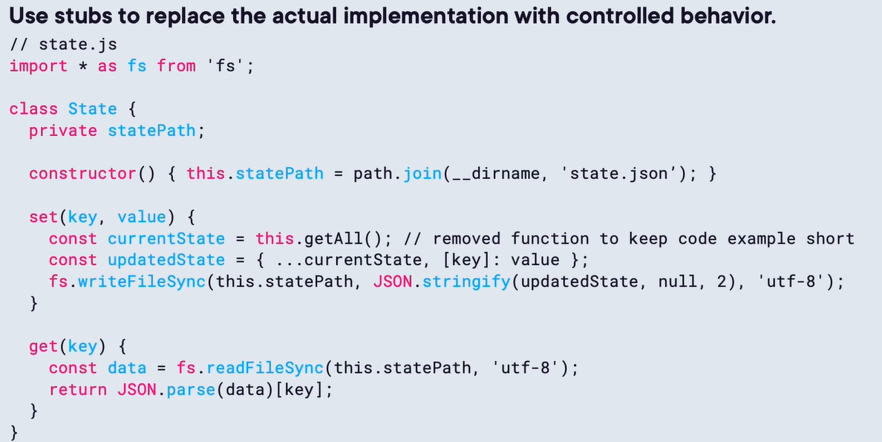

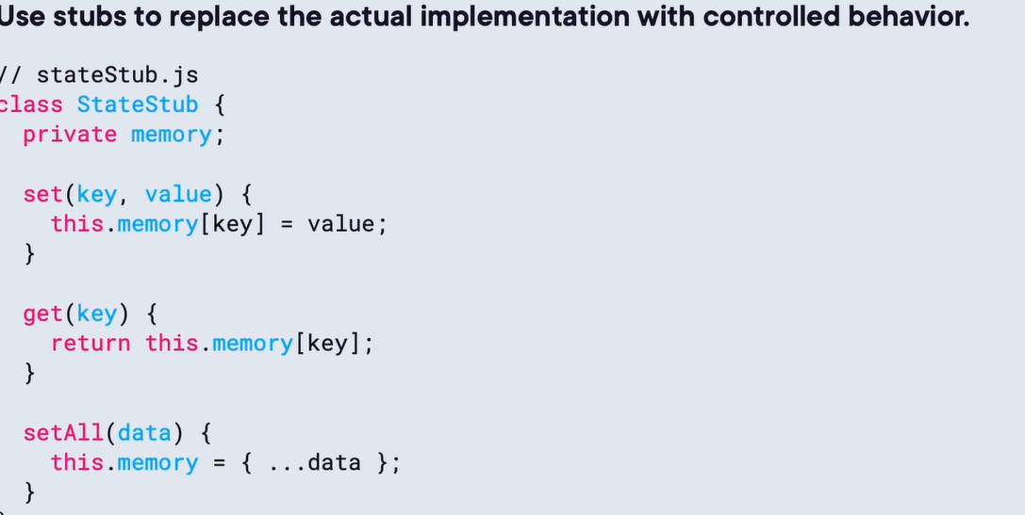

Use spies to verify side effects, also remember to clean up the spy once we are done. The Spy doesn’t replace the behavior, it just tracks it, we don’t test the internal logic –

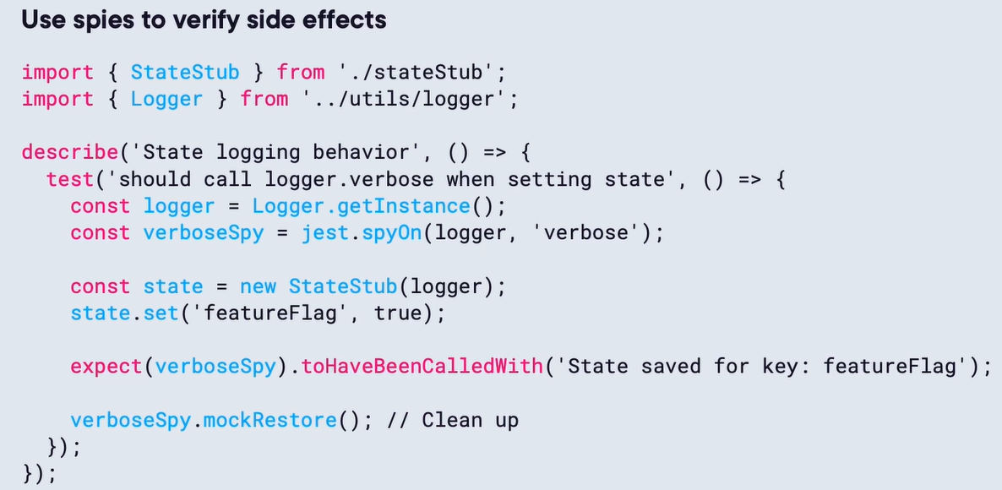

Rule 7 – Use realistic input data not like “Foo” –

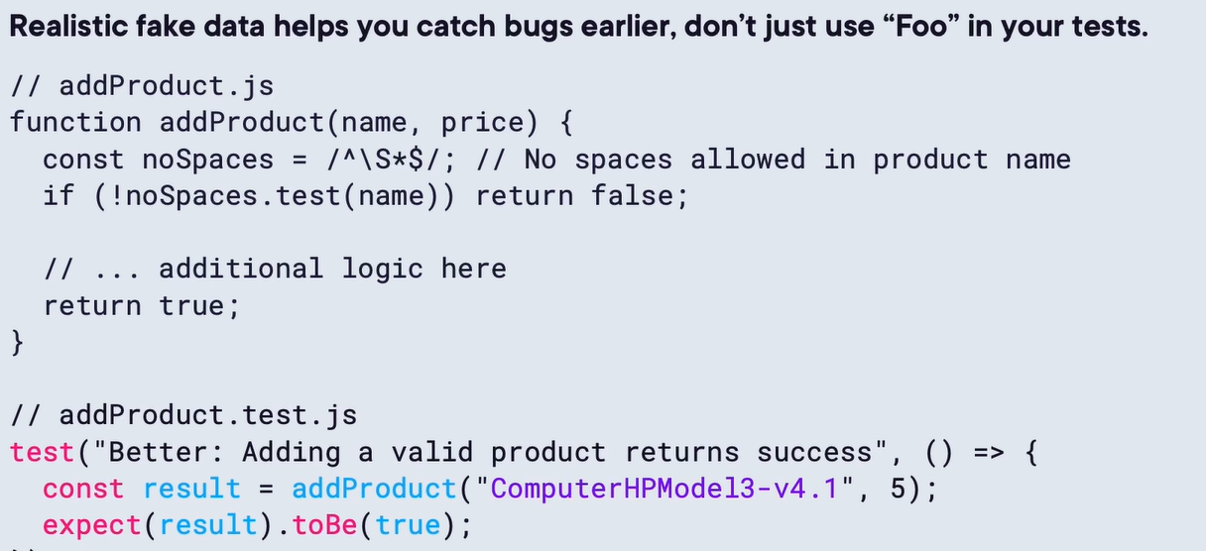

We can also use the fakerjs.dev library to generate the required proper fake data.

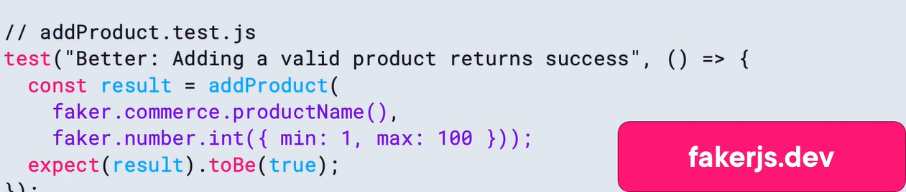

Rule 8 – Don’t catch errors, expect them –

Instead of this

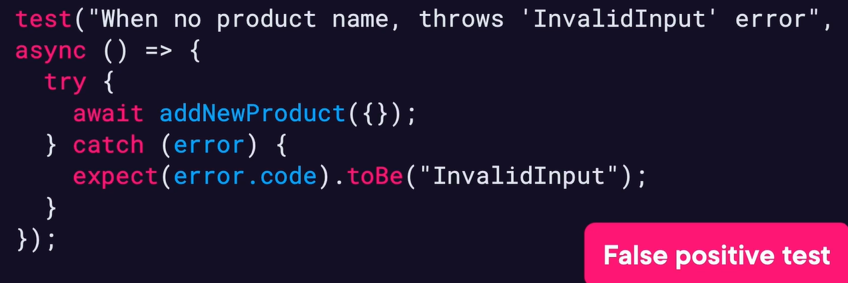

Use this

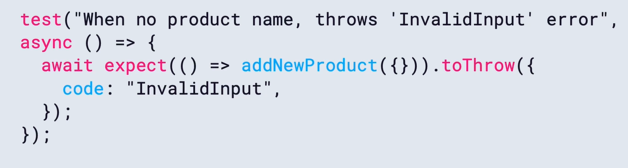

Rule 9 – Test the response schema when fields are dynamic (schema-style assertions)

Instead of this

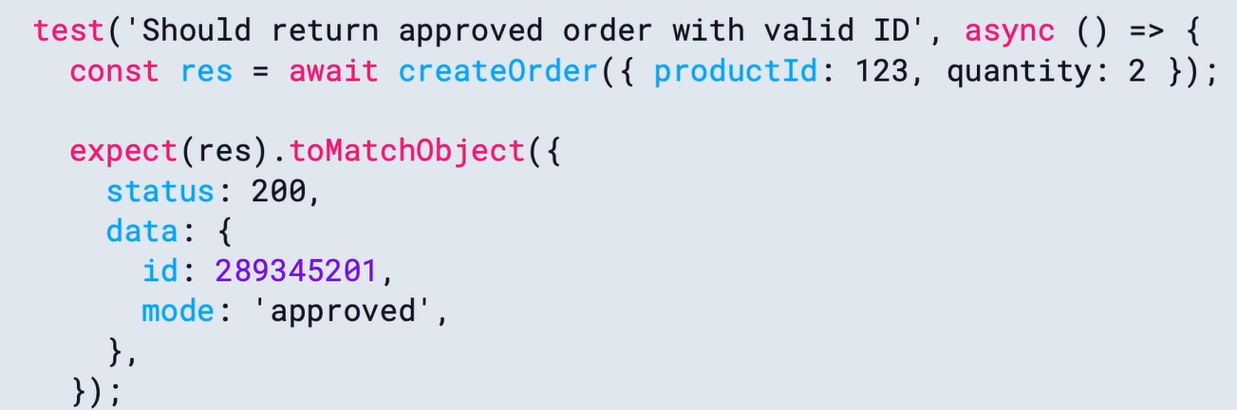

Use this

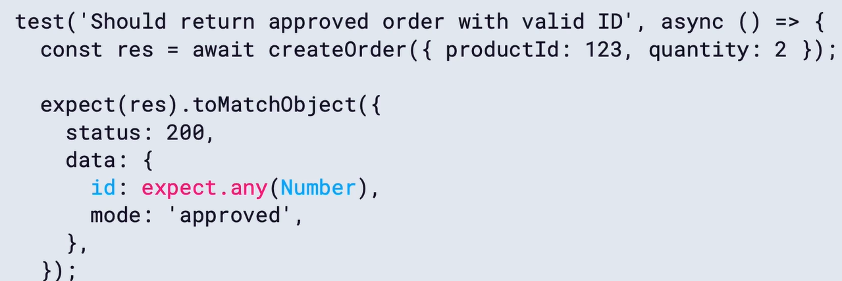

For heavy payload related scenario we can use schema validation library like Joi, this made test become less fragile when dealing with dynamic data changes.

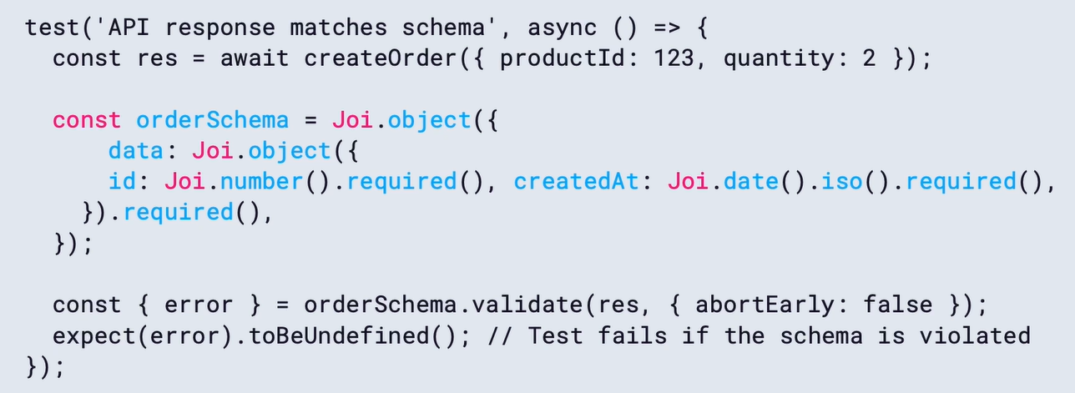

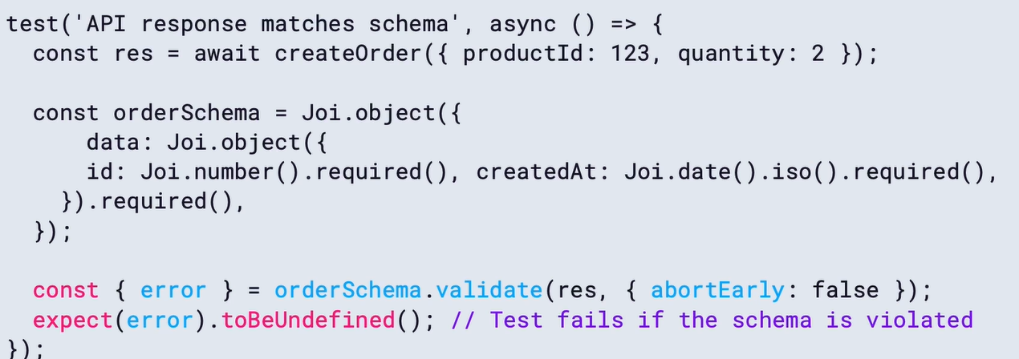

Rule 10 – use Fake timers to avoid time-based flakiness –

Instead of this

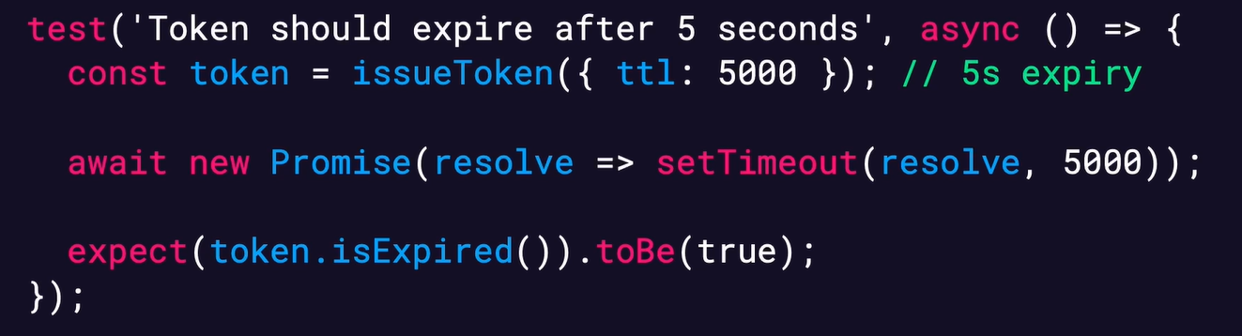

Use this

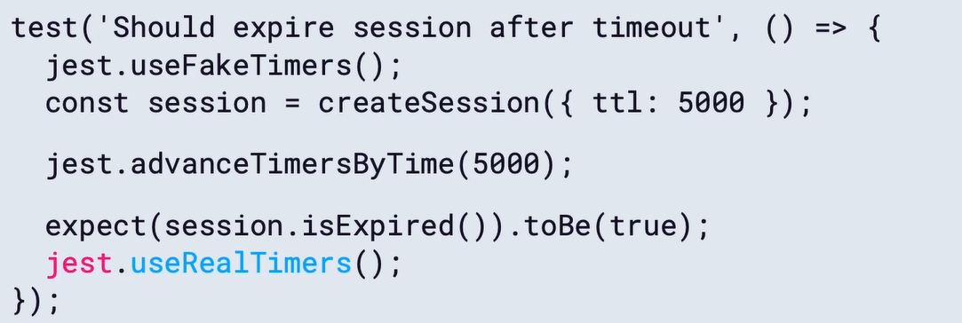

Spies – wrap a real function, allowing it to run normally while recording how it was used. They allow to call the method normally without returning any mock result.

DRY doesn’t mean overengineering test helpers, keep them simple. The goal is to reduce repetition without hiding what the test is doing.

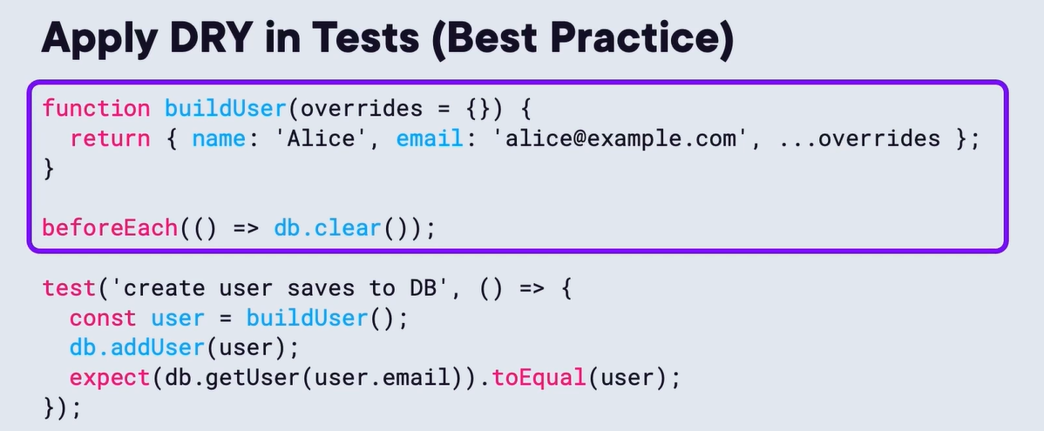

## TypeScript Foundations: Arrays and Collections

Read-only arrays –

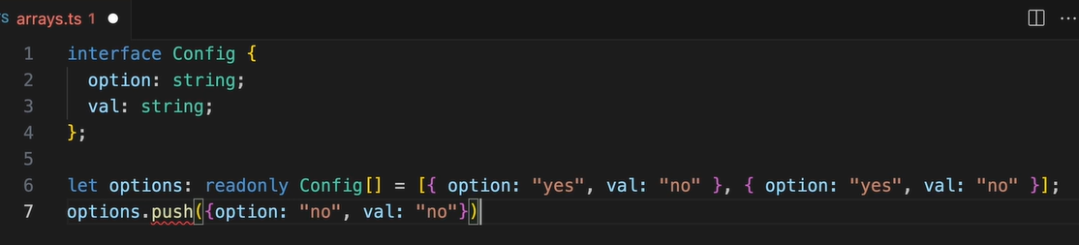

We can also pass it in function parameters –

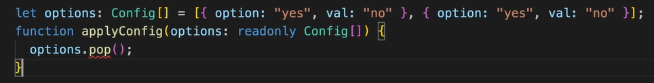

Tuples – fixed length and type, it is provided by TS not JS. We can also mark them read-only. Tuples can also contains duplicate value –

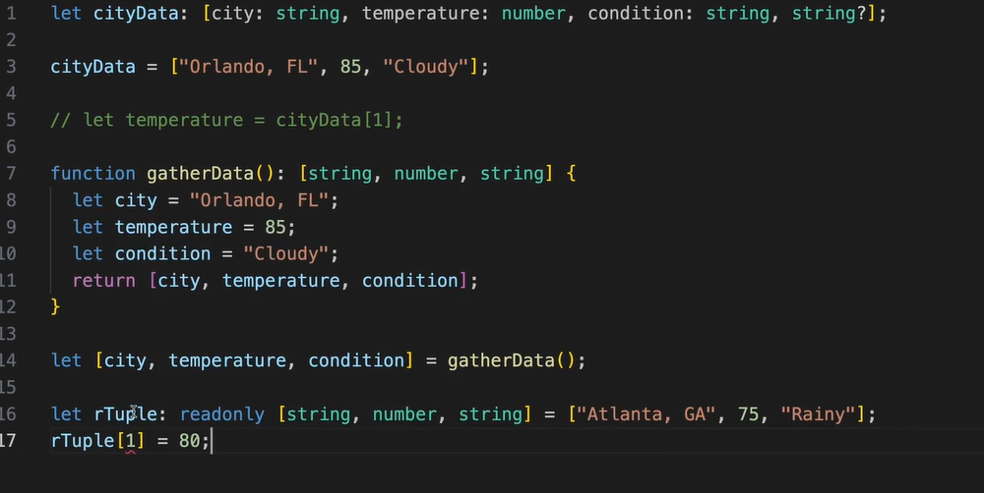

The main use case of the tuple is to return multiple values from the function.

Using object instead of tuples have one advantage i.e. to have true named parameter, also in object we can add new rules without worrying about index positions –

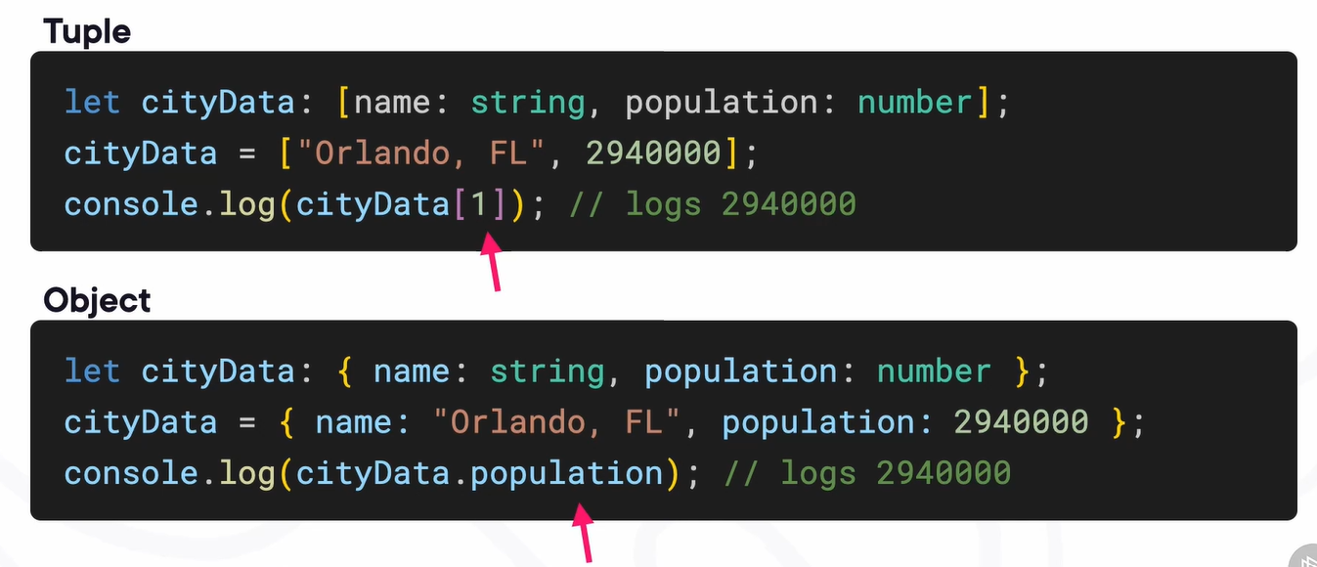

Sets – only contains unique value which is the main use case of using them. Also, the values are not sortable as they follow insertion order. Values aren’t indexed at all, instead we look up by value.

To make the set read-only we need to use a specific keyword ReadonlySet like below –

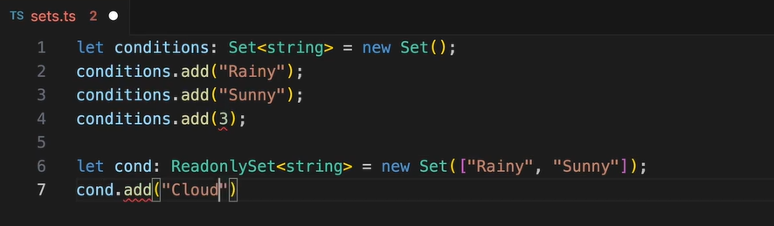

Maps – it is a way to associated values with a key. Using ReadonlyMap –

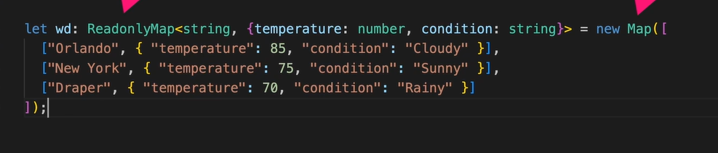

Comparing typescript collections –

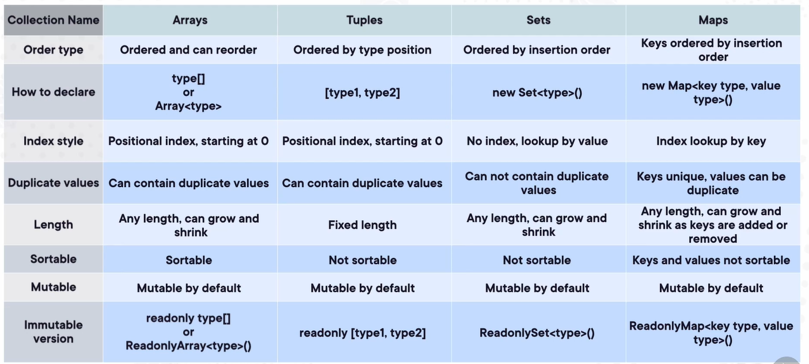

## TypeScript Foundations: Object-oriented Programming in TypeScript

There is a new access modifier by name readonly which is also allowed to set in the constructor and can’t not be reassigned.

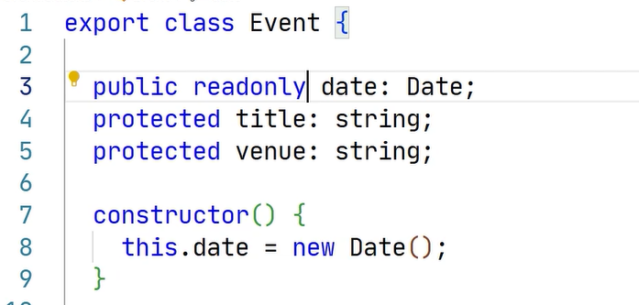

# TypeScript

OOP’s - OOP isn’t good or bad. It’s a collection of tools. Every tool has a cost. Use them deliberately, not religiously.

